Fall Horse Show
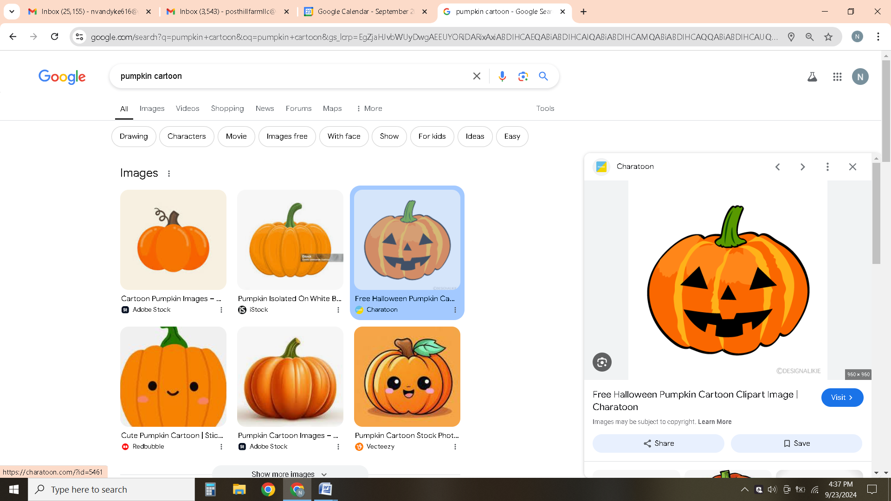
October 19th, 2025
Open Date: October 1st, 2025
Close Date: October 13th, 2025
Judge: Katie Aurand
**Special Award-High Score and Reserve High Score for the day will win a special prize**
We are excited to announce our Fall Horse Show for Post Hill riding students. This event will give students the chance to showcase the skills they have been working on in lessons while sharing their progress with family and friends. It is also a wonderful way for riders to connect with one another and celebrate the Post Hill community. Awards will be presented to top riders in each class.
All proceeds from the show will go directly toward improvements at the barn. In past years, funds have helped us replace multiple roofs, and we look forward to continuing to make upgrades that will benefit both our students and our horses.
The day will include more than just riding. Guests can enjoy fun fall activities, and refreshments will be available for purchase.
Riders should wear a neat shirt and clean pants, and boots should be polished. Helmets are required, and Post Hill helmets are available for students who do not have their own. While official show attire is not required, we encourage a clean and professional appearance.
We look forward to celebrating our riders’ hard work and enjoying a fun-filled fall day together at the barn!
Schedule of Events
Start Time 8:00am
***A schedule of ride times will be posted a couple of days after the close date.
- Intermediate Walk/Trot
- Intermediate Walk/Trot/Canter
***Intermediate Awards
- Beginner Walk/Trot
- Beginner Walk/Trot/Canter
- Adult Walk/Trot
- Adult Walk/Trot/Canter
***Beginner/Adult Awards
- Advanced Walk/Trot
- Advanced Walk/Trot/Canter
***Advanced Awards/Adult Awards

Entry Fees: $30 per class

Each rider will be given a couple minutes of warm-up with Miss Peggy prior to entering their class.

Each student is allowed to enter one class. If riders would like to enter both classes at their riding level, they may designate this on their entry form. If space permits, we will allow riders to ride in more than one class.

Riders may choose their top three choices for horses. Horses will be assigned based on their fit and availability. (The number of classes each horse competes in will be limited.)
We reserve the right to make changes to rider and horse combinations as well as class changes. Safety for horse and rider is always top priority followed closely by horse welfare.

Entry Form

Name:_______________________________ Phone Number:______________________

Email:___________________________________

Please circle the class you would like to enter. ($30 per class)

Class 1- Intermediate Walk/Trot Class 2- Intermediate Walk/Trot/Canter

Class 3- Beginner Walk/Trot Class 4- Beginner Walk/Trot/Canter

Class 5- Adult Walk/Trot Class 6- Adult Walk/Trot/Canter

Class 7- Advanced Walk/Trot Class 8- Advanced Walk/Trot/Canter

Please indicate your top three horse choices:
(Dare, Thunder, Chrissy, Fannie, Gypsy, Kazper, Niko, Abby)
***Clients may also ride personal horses not listed.

1._____________________2.___________________3.______________________

Subtotal Class Fees ($30 per class) _______

Late Fee $10 (After October 13) _______

Total: ______

Rules/Disclosure
Post Hill Farm LLC and its employees will not be held responsible for loss or damage to persons, property, or horse. No dogs allowed. No smoking.

If you sign up for more than one class and we are unable to accommodate, Post Hill will refund the second class. Management reserves the right to make changes to the show if necessary including but not limited to schedule changes, horse changes, judge changes, and ect.

We cannot guarantee that riders will get their first horse choice. Entries are limited and will be on a first come first serve basis.

Cancellations: Prior to close date will be refunded 100%. After close date, but prior to 24 hours to horse show will be refunded 50%. No refunds will be given within 24 hours of horse show.

I have read and understand the rules/disclosure statements above.

____________________________________Signature (Parent if under 18)_________________Date

