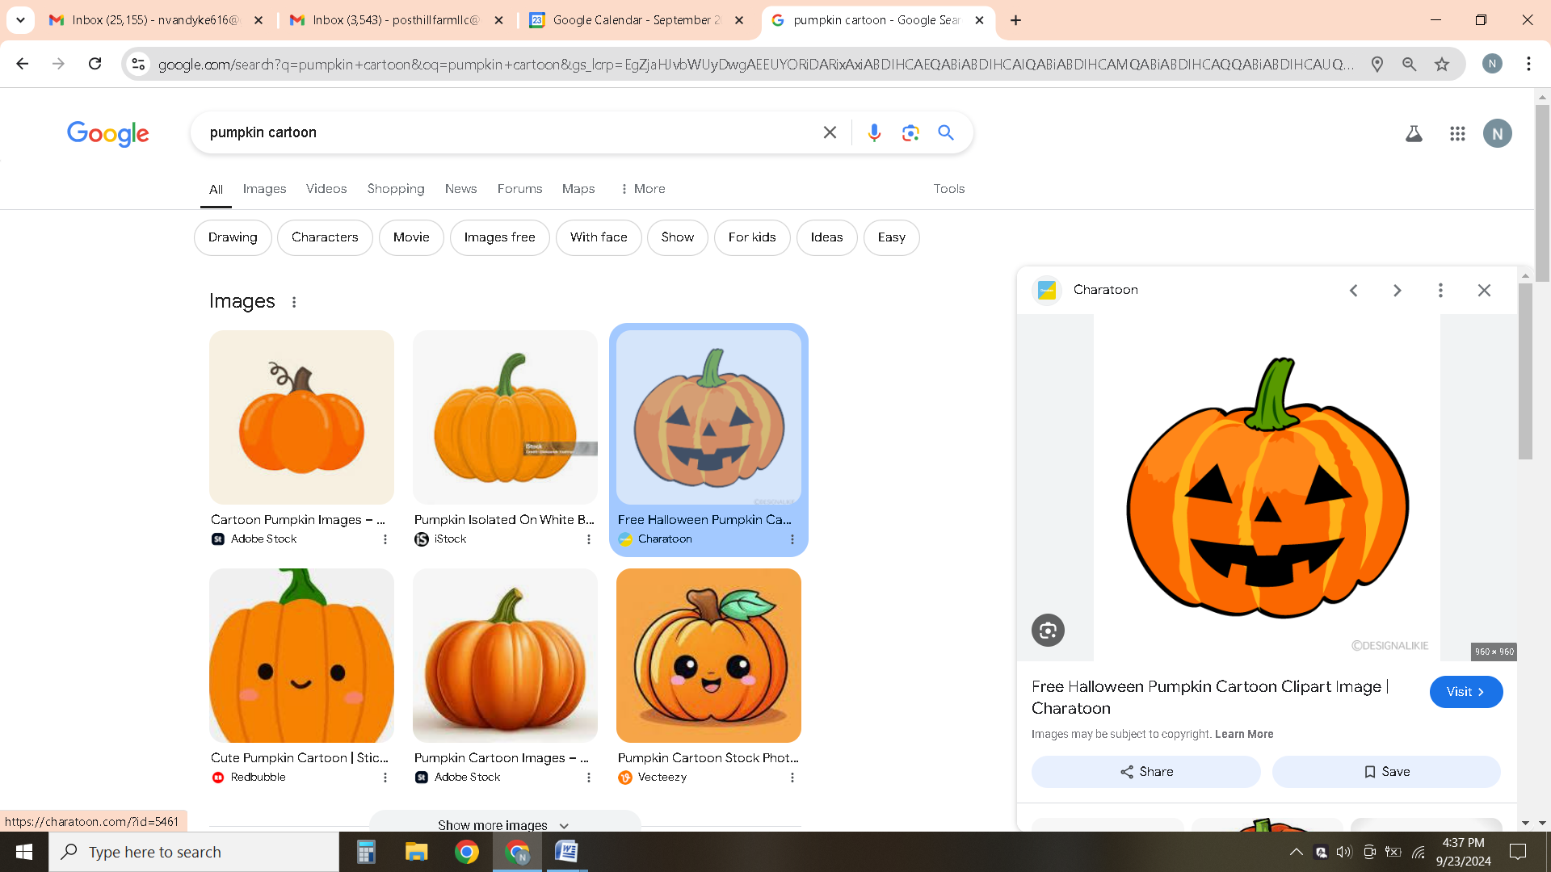
Fall Horse Show
October 18, 2026
Open Date: September 22, 2026
Close Date: October 12, 2026
Judge: Jeannine Palozzi Jedlicka
We are excited to be offering a Fall Horse Show for Post Hill riding students. This horse show will give students the opportunity to show off the skills they are learning in lessons to their families. It will also give them the opportunity to meet other riders at Post Hill. Awards will be given to top riders in each class.
All of our horse show proceeds go to making improvements at the barn. In years past, the money raised has gone to replace multiple roofs. We hope to continue to make improvements and upgrades, so that Post Hill continues to be a great place for students to learn about horses and riding.
The horse show will be more than just riding! We plan to have a couple of fun Fall activities. There will also be refreshments available for purchase. We are also excited to offer a special award this year called, The Joy of Riding Award.
The Joy of Riding Award: Presented to the rider who demonstrates a genuine love and enthusiasm for riding and for their horse. This rider finds joy in every moment spent in the saddle, approaches each ride with a positive attitude, and embraces the opportunity to learn and improve. They demonstrate thoughtful horsemanship, kindness and respect toward their horse, and a willingness to work as a team.
This award celebrates the rider who reminds us that riding is about more than ribbons and competition—it is about the partnership, the learning, the challenges, and most importantly, the joy that comes from simply being with a horse.
Attire: Riders should wear a nice shirt and clean pants. Boots should be cleaned. We do not require official show attire, but do recommend a professional look. Helmets are required. (Students without helmets can use Post Hill school helmets.)

Schedule of Events
Start Time 8:00am
***A schedule of ride times will be posted a couple of days after the close date.
- Intermediate Walk/Trot
- Intermediate Walk/Trot/Canter
- Beginner Walk/Trot
- Beginner Walk/Trot/Canter
- Adult Walk/Trot
- Adult Walk/Trot/Canter
***Beginner/Intermediate/Adult Awards
***Intermission
- Advanced Walk/Trot
- Advanced Walk/Trot/Canter
***Advanced Awards/Adult Awards

Entry Fees: $30 per class

Each rider will be given a couple minutes of warm-up with Miss Peggy prior to entering their class.

Each student is allowed to enter one class. If riders would like to enter both classes at their riding level, they may designate this on their entry form. If space permits, we will allow riders to ride in more than one class.

Riders may choose their top three choices for horses. Horses will be assigned based on their fit and availability. (The number of classes each horse competes in will be limited.)
We reserve the right to make changes to rider and horse combinations as well as class changes. Safety for horse and rider is always top priority followed closely by horse welfare.

Entry Form

Name:_______________________________ Phone Number:______________________

Email:___________________________________

Please circle the class you would like to enter. ($30 per class)

Class 1- Intermediate Walk/Trot Class 2- Intermediate Walk/Trot/Canter

Class 3- Beginner Walk/Trot Class 4- Beginner Walk/Trot/Canter

Class 5- Adult Walk/Trot Class 6- Adult Walk/Trot/Canter

Class 7- Advanced Walk/Trot Class 8- Advanced Walk/Trot/Canter

Please indicate your top three horse choices:
(Dare, Thunder, Chrissy, Bentley, Fannie, Gypsy, Kazper)
***Clients may also ride personal horses not listed.

1._____________________2.___________________3.______________________

Subtotal Class Fees ($30 per class) _______

Late Fee $10 (After October 12) _______

Total: ______

Rules/Disclosure
Post Hill Farm LLC and its employees will not be held responsible for loss or damage to persons, property, or horse. No dogs allowed. No smoking.

If you sign up for more than one class and we are unable to accommodate, Post Hill will refund the second class. Management reserves the right to make changes to the show if necessary including but not limited to schedule changes, horse changes, judge changes, and ect.

We cannot guarantee that riders will get their first horse choice. Entries are limited and will be on a first come first serve basis.

Cancellations: Prior to close date will be refunded 100%. After close date, but prior to 24 hours to horse show will be refunded 50%. No refunds will be given within 24 hours of horse show.

I have read and understand the rules/disclosure statements above.

____________________________________Signature (Parent if under 18)_________________Date

